**Final Project: Analysis of Long-Term Unemployment in the United States of America**

Kristin Scully

Anderson College of Business and Computing, Regis University

MSDS 670: Data Visualization

John Koenig

March 10, 2021

This final project uses data from the provided data folder provided by Mr. John Koenig for the MSDS 670: Data Visualization course. This data includes the number of unemployed people from January 2005 to February 2015. It covers both men and women and several age groups. I have analyzed the unemployment of men vs women over time as well as the different age groups that were unemployed during and after the great recession.

Unemployment of men and women remained about the same from 2005 till about the end of 2008. The great recession, which started in December 2007 and ended in June 2009, marked the beginning of a steep rise in men being unemployed. By mid-2008 both men and women were seeing a rise in long term unemployment. From this mid-2008 point men were experiencing long term unemployment greater than their female counterparts, peaking in early 2010. Unemployment began to creep back down until early 2015, when men and women started to see a more equal presentation of long term unemployment.

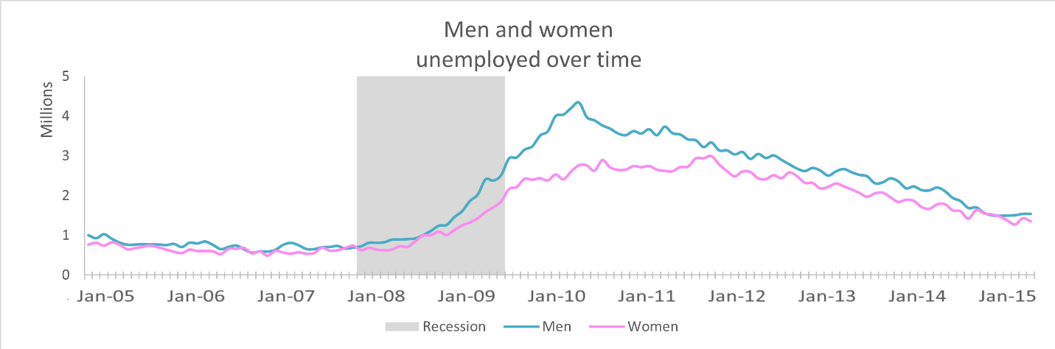

Teenagers and people of retirement age and older are the least unemployed without much change after the great recession. They may have the least number of people in the work force. People between the ages of 25 and 54 were the most unemployed of all age groups. They saw a large uptick in unemployment from the recession peaking in early 2010.

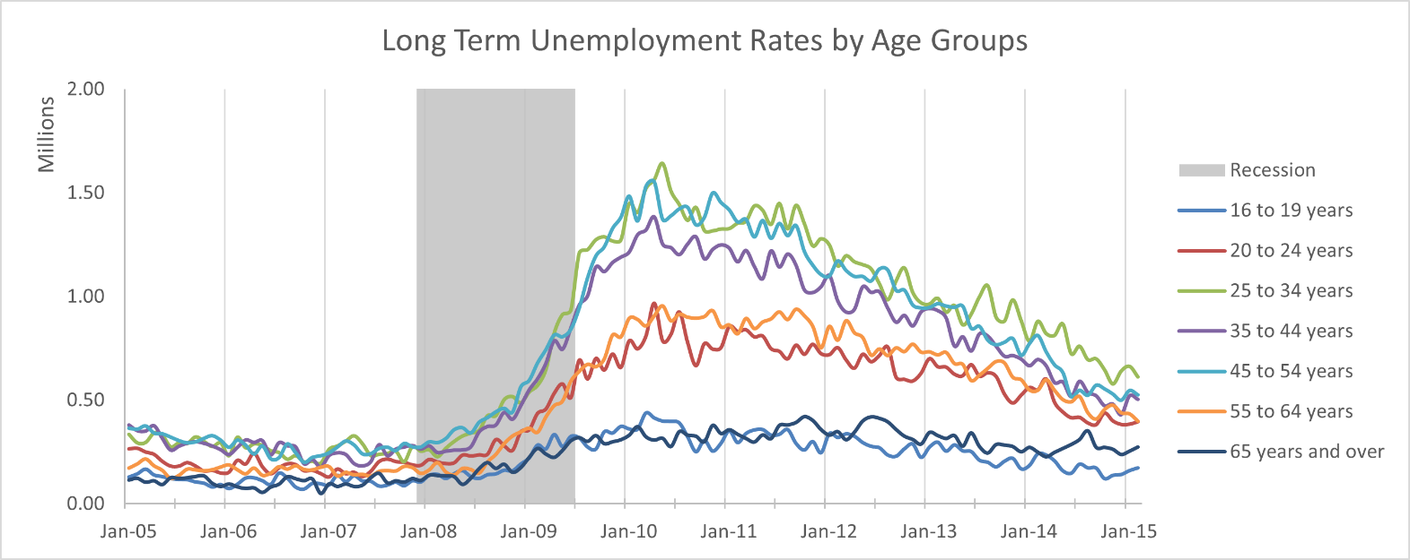

Men had a higher number of unemployment over all, with maximums reaching one-million, while women capped out around 750K. Men ages 25-34 were the first to see large unemployment numbers resulting from the recession during late 2008. This group of people saw the greatest unemployment numbers overall reaching around 1M from March to July 2010. Unemployment numbers for women peaked a bit later for ages 25-34, around July to September 2011. In both genders the most unemployment was seen in ages 25-54 from September 2008 to mid 2013, while those aged 25-34 had the slowest recovery.

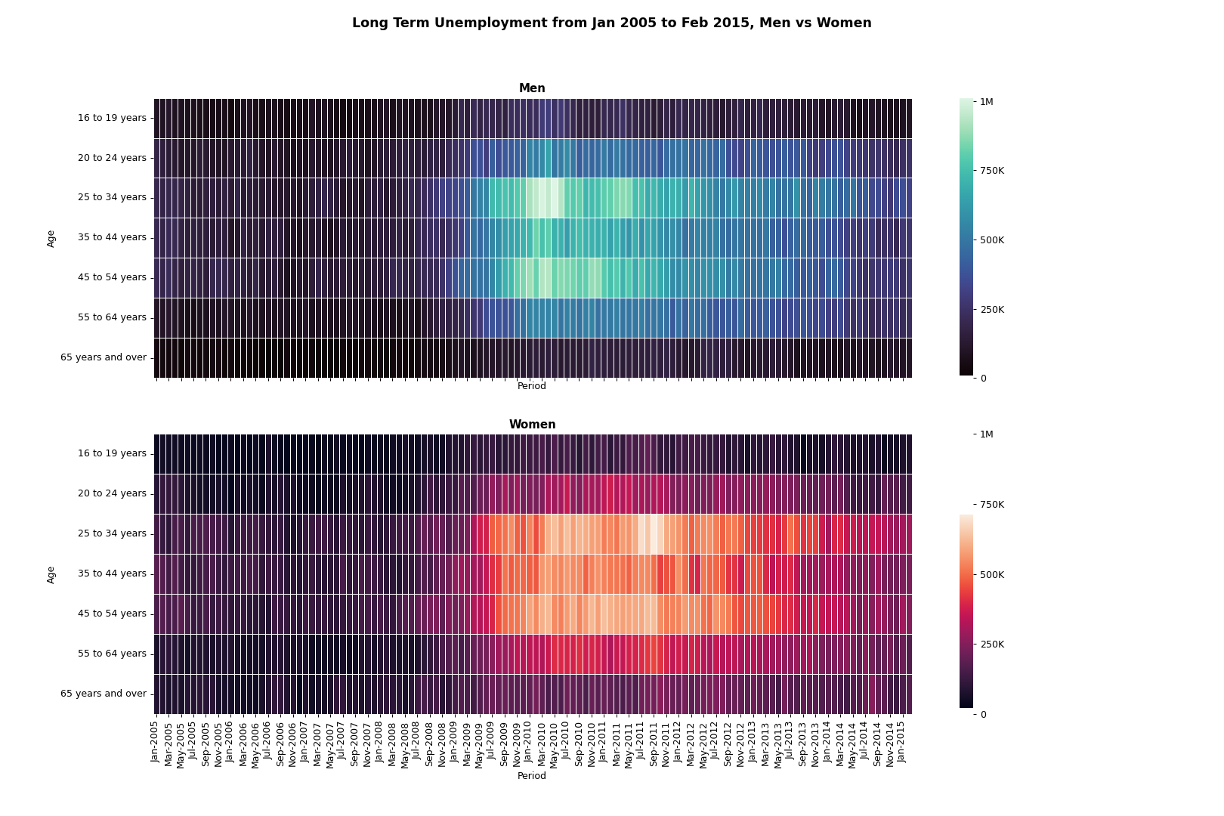

The great recession was a challenging time for everyone in the workforce. What we do not know from this data is the number of people that were in the workforce to begin with. For example, did women have smaller unemployment overall because there were less women in the workforce? Are there social reasons for men having larger unemployment numbers?

**References**

Weinberg, J. (2013, November 22). *The great recession and its aftermath*. Federal Reserve History. https://www.federalreservehistory.org/essays/great-recession-and-its-aftermath